Time: 60 minutes
Directions: Each of the 30 multiple-choice questions is followed by five possible answer choices. Choices A through D will provide answers, while Choice E is for none of the above. Scoring will be as follows: 5 points for a correct answer, 0 for a wrong answer, and 1 for a blank answer (for a maximum possible score of 150). Figures are not necessarily drawn to scale. Do not choose incomplete answers: if a question has more than one solution, do not select a choice that only provides one of the solutions! Figures provided are not necessarily drawn to scale.
Calculators are not permitted.
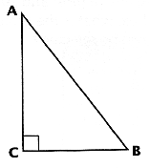
1) If I am Sam, then I do not like green eggs and ham. The converse of this statement must be:
A) If I am not Sam, then I do like green eggs and ham
B) If I am Sam, then I do like green eggs and ham.
C) If I do not like green eggs and ham, then I am Sam
D) If I do like green eggs and ham, then I am not Sam. E) NOTA
Someone has offered Sam some green eggs and ham. Sam runs
off to avoid having to eat the green eggs and ham, traveling
away from it (point A), running to point B, and then to
point C, creating a Pythagorean triple, with side AB having a
length of 5.
Use this information to answer questions 2 and 3

2) What is the total area of the triangle?
A) 6 B) 7.5 C) 9 D) 15 E) NOTA

3) If Sam is at point C, and he walks to a point, Q, on side AB, so that CQ is perpendicular to AB. What is the length of CQ?
A) 9 B) 5 C) 12 D) Can not be determined E) NOTA
5 2 5

4) Which two points can be found outside a triangle?
A) Incenter and Circumcenter B) Orthocenter and Centroid
C) Centroid and Incenter D) Circumcenter and Orthocenter E) NOTA

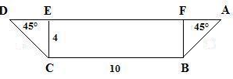
5) Sam would not eat green eggs and ham in a boat. Sam’s boat, from the side, looks like an isosceles trapezoid with base angles measuring 45°. If the lower base has a length of 10 ft, and the altitude has a length of 4ft, find the area of the trapezoid.

A) 48 ft² B) 56 ft² C) 86 ft²
D) 112 ft² E) NOTA

6) Sam encounters a box with dimensions 6 by 5 by 4. On the box is a note that reads, “If you can find the surface area of this box, you can have what is in it.” Find the surface area.

A) 120 B) 139 C) 148 D) 154 E) NOTA

7) Sam opens the box and – uh oh! - He finds a spherical green egg of diameter 6. Find the volume of the egg.

A) 18 π B) 36 π C) 144 π D) 288 π E) NOTA

8) Sam finds another box with another spherical green egg inscribed in a cube of side length 8. What would be the egg’s surface area?

A) 36 π B) 64 π C) 144 π D) 256 π E) NOTA

9) The sides of triangle HAM have measures 9, 12, and 15. Find the area.

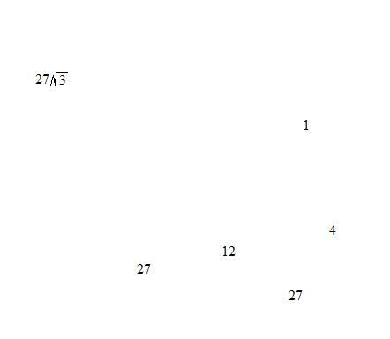
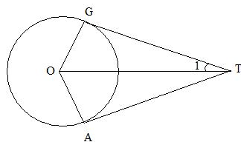
A) 27 B) 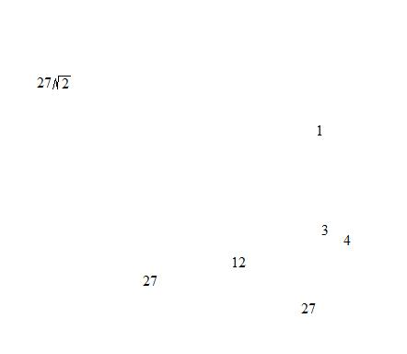 C) D) 54 E) NOTA
__ __
10) GT and AT are tangents. Find m‹1 if m‹O = 160º

A) 10 B) 15 C) 20
D) Cannot be determined E) NOTA
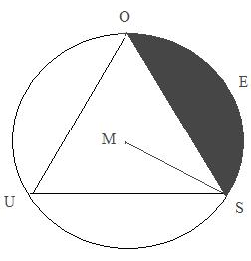

11) Find the area of the shaded segment formed by an inscribed equilateral triangle if the radius is 6.
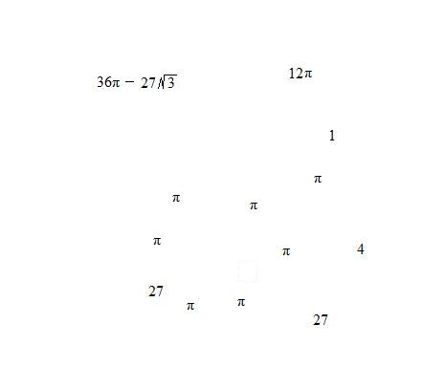
A) 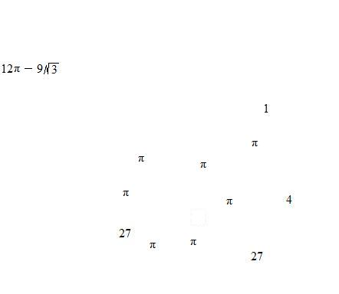 B) 12π _ 9 C)

D) 36π _ 81 E) NOTA

12) A rhombus RAIN has diagonals of lengths 12 and 16. What is the perimeter of the rhombus?

A) 28 B) 36 C) 40 D) 48 E) NOTA
__ __ __
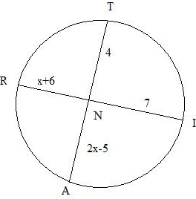
13) Segments TA and RI are chords of circle N. Find the length of TA.

A) 62 B) 73 C) 119

D) 123 E) NOTA

14) Sam-I-Am picks up a circular piece of ham with a radius of 6. Find the area of a 60 º sector of the ham.

A) 2π B) 4π C) 6π D) 12π E) NOTA

15) Disgusted by the sight of the ham, Sam starts to run away from it. He first runs 3 miles due south, 7 miles due west, 6 miles due north, and finally 3 miles due east before he decides he is far enough away from the ham. How far away is Sam-I-Am away from his starting point?
_ __
A) √5 miles B) 5 miles C) √10 miles D) 25 miles E) NOTA

16) Sam is running out of excuses for not eating green eggs and ham. As a last attempt, Sam says that he will not eat it because it is not yet dinner time. What is the measure of the angle formed from the hands of a clock when it is 3:14?

A) 6º B) 7º C) 12º D) 13º E) NOTA

17) Giving in to peer pressure, Sam decides that he will take a chance and try some green eggs and ham. His plate is a square and his portion of green eggs and ham fills up half of it. If he has 18 square units of green eggs and ham, what is the diagonal of his bowl?
_ _ _ _
A) 3√2 B) 4√2 C) 6√2 D) 9√2 E) NOTA

18) The circumference of a circle is aπ units, and the area of the circle is bπ square units. If a = b, what is the radius (in units) of the circle?

A) 1 B) 2 C) 3 D) Can not be determined E) NOTA

19) What is the geometric mean of -3 and 27?

A) – 9 B) – 6 C) 9 D) 12 E) NOTA

20) Due to Sam’s increase in appetite for green eggs and ham, he decides to buy a new plate. His new plate has a surface area that is 50% more than the original. If the original plate had a diameter of 12 inches, what is the radius of his new plate?
_ _
A) 3 B) 3√6 C) 9 D) 6√3 E) NOTA

21) What is the sum of the measures of the interior angels in a dodecagon?

A) 1080 B) 1440 C) 1800 D) 2160 E) NOTA

22) What is the distance between E (3, 4) and G (7, 1)?
A) 3 B) 4 C) 5 D) 6 E) NOTA

23) If the vertices of a regular polygon inscribed in a circle divide the circle into arcs of 40º each, what is the polygon?
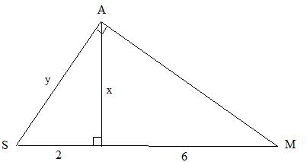
A) Pentagon B) Hexagon C) Heptagon D) Nonagon E) NOTA

24) Find x + y
_ _ _
A) 2√3 B) 3√3 C) 2√2 + 3
_
D) 2√3 + 4 E) NOTA

25) If the difference between the two smaller angles of a right triangle is 46º, what is the measure, in degrees, of the smallest angle?
A) 22º B) 44º C) 46º D) 68º E) NOTA

26) Sam loves geometry so much that his stomach is now a hexagon with side length 4. He also loves to eat green eggs and ham. If Sam’s stomach is one-fourth full of digested green eggs and ham, what is the area of the empty part of his stomach?
_ _ _ _
A) 6√3 B) 12√3 C) 18√3 D) 24√3 E) NOTA
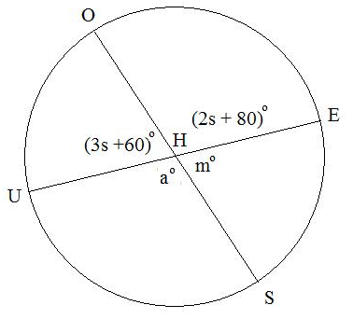
27) Find s + a + m when OS and UE are
diameters of circle H.

A) 84 B) 96 C) 138

D) 188 E) NOTA

28) A polyhedron has 66 edges and 39 vertices.
How many faces does it have?

A) 29 B) 32 C) 33 D) 39 E) NOTA

29) What is the smallest integer, x, for which x, x+7, and 3x-17 can be the lengths of the sides of a triangle?

A) 6 B) 7 C) 8 D) 9 E) NOTA

30) What is the area bounded by the x-axis, the y-axis, and 14x + 7y = 91 to the nearest square unit.

A) 41 B) 42 C) 43 D) 44 E) NOTA

